An Analysis of Progress Across Continents
Towards the UN Sustainable Development Goal 8
Chiakala Emezie, Rong Xuan Mah, Alif Mohammed, Siheon Lee, Jessica Zhang
1 INTRODUCTION
The United Nations Sustainable Development Goals (SDGs) outline a global framework for achieving inclusive and sustainable progress by 2030. In this report, we are focusing on SDG 8: Decent Work and Economic Growth. This goal promotes sustained, inclusive and sustainable economic growth, full and productive employment and decent work for all.

We will evaluate how six continents are progressing towards SDG 8 by analysing key indicators related to economic growth and youth labour market outcomes. We will focus on assessing progress toward two UN targets: sustaining per-capita economic growth and reducing the proportion of youth not in employment, education or training (NEET). Using the provided datasets on continental classifications, GDP per capita and youth NEET rates, we will conduct exploratory data analysis to compare developments over time and across regions.

To start, we started by defining specific target GDP per capita growth rates and youth NEET shares. Least Developed Countries (LDCs) are expected to achieve at least 7% annual GDP per capita growth, representing the most ambitious target within SDG 8.1. In contrast, the SDGs provide no specific numerical requirement for other countries, instead calling for “sustained per capita economic growth.” In the European context, the European Commission’s Autumn 2025 Economic Forecast reported nominal GDP per capita growth of about 3.5% as exceptional growth. Because LDCs target 7% growth while advanced economies typically consider 3% to be solid, a target of 5% can be viewed as a reasonable midpoint, a general goal for all other countries.

The UN doesn’t specify a concrete numerical target for youth NEET reduction. However, the UN SDG Report notes that a 10-15 percent decline in youth NEET rates, such as those observed in Oceania and Central and Southern Asia since 2015, is considered a "modest" but acceptable improvement. To establish a more explicit quantitative benchmark, this analysis draws on the Antalya Goal calling for a 15 percent reduction by 2025 among G20 nations. In the European context, the European Pillar of Social Rights Action Plan sets a more ambitious goal: reducing the EU youth NEET rate from 12.6 percent to 9 percent by 2030, a 29 percent proportional decline.

2 METHODOLOGY
The data provided to us included three CSV files. We then added a fourth CSV file, allowing us to conduct deeper data analysis. The following table summarises these files.
File Name | Content
continents-according-to-our-world-in-data.csv | - Used to classify countries by continent
gdp-per-capita-worldbank.csv | - Used to find yearly GDP per capita for each country that the data is available
youth-not-in-education-employment-training.csv | - Used to find youth NEET percentages for each country that the data is available
K12-custom.csv | - Six columns: entity, country code, least developed country (LDC) classification, ease of doing business index, and human development index (HDI)
The custom CSV was created from three sources. The LDC classification came from the latest UN Committee for Policy Development report and was used to assess whether LDCs met the concrete 7% GDP per capita growth target set by the UNSDG. The ease of doing business index came from the World Bank’s Doing Business 2020 report. Finally, the human development index (HDI) came from the UNDP 2025 Human Development report.
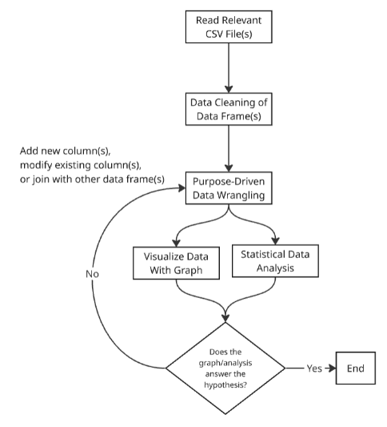
To address our questions on GDP per capita and youth NEET trends, we created graphs comparing continents over time and, within Europe, development groups. Our analysis relied on three categories: (1) tidyverse data frame manipulation, (2) ggplot-related graphing, and (3) miscellaneous data wrangling. Figure 1 provides an overview of our analytical process.

We added detail to the graphs using stat_summary for quartile values, and aes() parameters (colour, linetype, and group) to group datapoints by country, continent, or other features.
To address both SDG targets, we used ggplot visualisations, each with a specific purpose. Boxplots (geom_boxplot()) provided high-level summary statistics across continents and European development groups, allowing us to assess whether countries cluster above or below key benchmarks such as the 7% LDC growth target. Line plots (geom_line() and geom_point()) were used to explore time-series patterns, enabling clear comparisons of trajectories across regions and highlighting year-on-year variability for calculating changes between specific years.
Figure 1
We also used regression curves (geom_smooth(method = “loess”) to reveal longer-run trends in European GDP growth. This method accommodates non-linear patterns and outliers, making it well-suited for assessing progress toward the growth benchmark. Reference lines (geom_hline()) indicated target thresholds, providing a visual reference for assessing performance relative to the target. Finally, a scatter plot combined with a regression line supported correlation analysis, necessary for analysing the relevance of our custom CSV data with the target.

3a RESULTS – GDP GROWTH
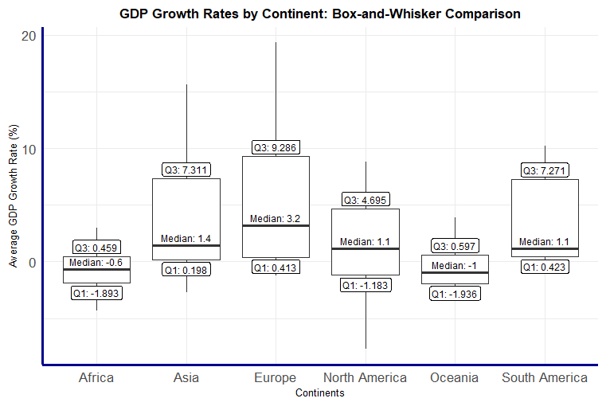
For Target 8.1, we compare GDP per capita growth across continents to assess the vicinity of each region towards their respective targets, according to their national circumstances. From figure 2, we see that Asia has the strongest overall performance, with the highest median and upper quartile values. In contrast, North America and Oceania show the weakest performances, with a median GDP per capita growth rate of 1.2% and sub-2% upper quartile values.
Figure 2
Africa shows a wider spread of GDP growth, with many exceeding 2% whilst many other nations experienced negative growth rates. Europe and South America have the same median value, but Europe experienced much higher GDP growth rate values that are greater than 3.5% in its upper quartile, which is driven by developing countries experiencing the benefit of the European Union and a relatively geopolitically stable region unlike Africa and Asia.
Overall (excluding outliers), only Asia and Europe began to reach the 5% modest growth target, while over a third of European countries successfully met the 3% growth target suggested by the European Commission.
Looking at individual years in Figure 3, during the 2000s, Asia’s growth frequently hits 5–7 percent, reflecting rapid industrialisation in several emerging economies. However, Asia still fails to sustain growth above 7 percent across time, indicating that high growth is difficult to maintain once economies begin to mature.
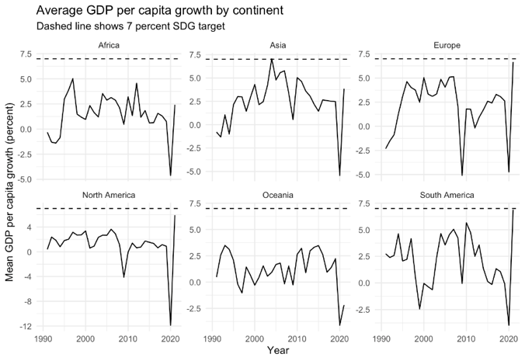
This contrasts with Africa. Africa is a region with many LDCs for which the 7 percent benchmark is most relevant. Africa shows moderate but volatile growth. While it occasionally achieves rates around 4–5 percent, it does not meet the SDG target. However South America also shows similar volatility as Africa. Both Africa and South America struggle to maintain stable growth, but Africa’s growth is slightly more stable, whereas South America experiences deeper fluctuations. Neither comes close to the 7 percent target, highlighting shared structural challenges.
Figure 3
Moving on to more developed economies, Europe and North America display stable but low growth, typically between 1 and 3 percent. Their growth paths are far smoother than those of Africa or South America. This contrast is in line with the target set out to assess growth “in accordance with national circumstances”. While LDCs are expected to pursue higher growth to catch up, developed economies are not expected to reach 7 percent.
Across all continents, the contraction in 2020 highlights global exposure to systemic shocks and the difficulty of maintaining long-term growth stability due to the Covid-19 pandemic.
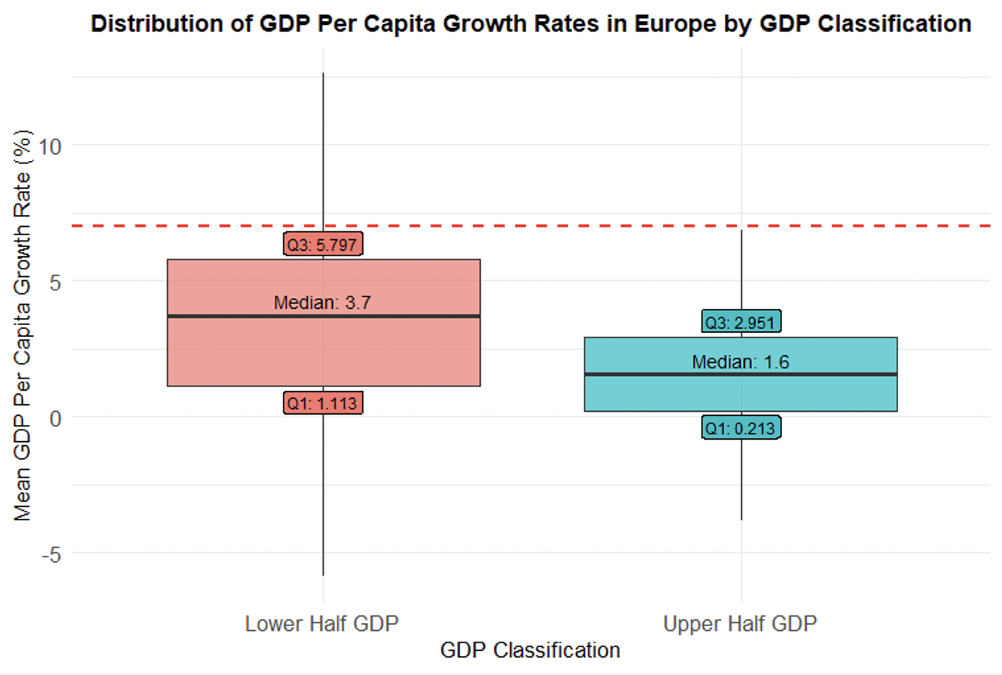
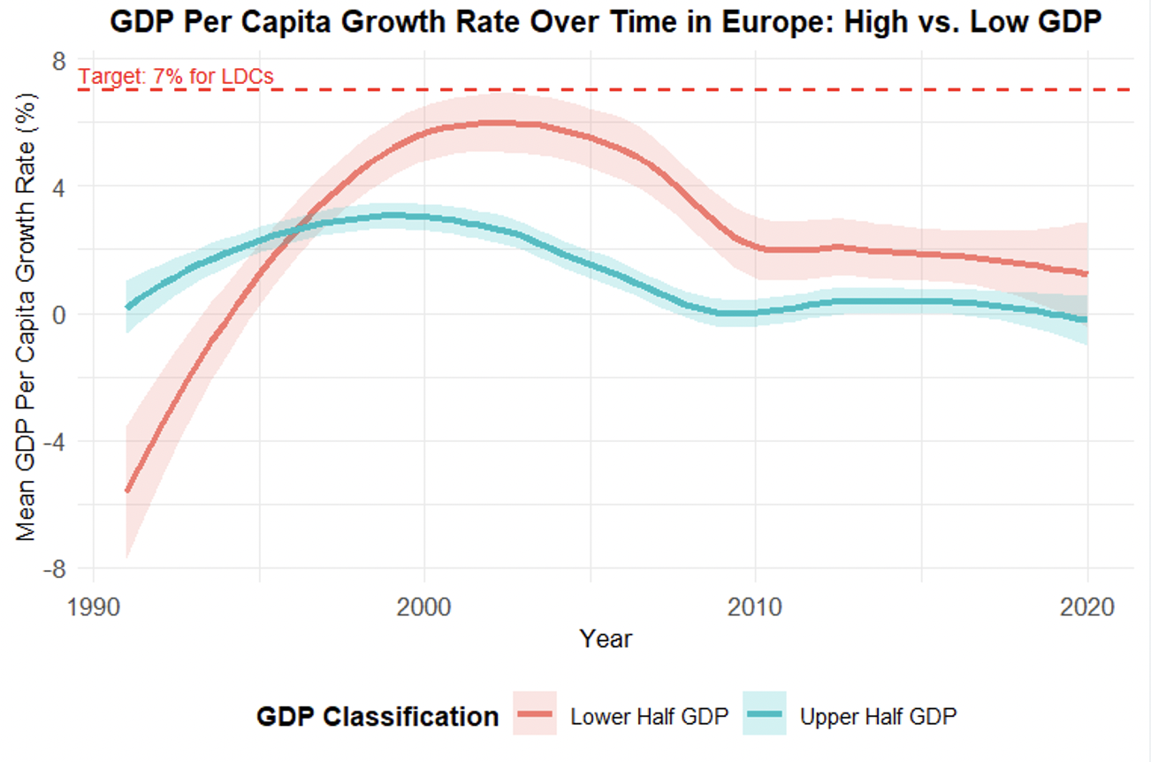
Europe was then examined in more detail. Specifically, the continent was divided into upper and lower half by median GDP per capita (2017 PPP USD). Figure 4 reveals that no European countries achieved the 7% annual GDP growth target between 1990 and 2020. This target, however, was aimed at LDCs and is not applicable to any European economy (UN DESA, 2024). Therefore, it was only used as a point of reference. Figure 4 shows that lower-half countries grew at an average of 3.35%, compared to 1.05% for the upper-half. Both groups fall below the 7% threshold.
Figure 4
However, Europe shows economic stability rather than rapid growth. Figure 5 reveals that more upper-half countries have a narrower range of growth rates, which 38.1% sustaining positive growth in over 80% of the 1990-2020 period. In contrast, lower-half countries show a wider spread with more outliers, and 47.6% achieved positive growth in over 80% of the period. This suggests that while less developed economies experienced more volatility, many sustained positive long-term performance.
Figure 5
Understanding these patterns requires context. Between 1990 and 2020, Europe experienced major structural changes such as the fall of the Soviet Union and the transition of Eastern European economies. These primarily affected the llower-half group (World Bank, 2002). Macroeconomic shocks like the 2008 financial crisis (OECD, 2009) and 2020 Covid-19 pandemic (European Commission, 2020) had broader effects across the continent. Given this context, the consistent growth of European countries reflects successful shock
These findings highlight that that the UN’s 7% target is unsuitable for Europe, where success is better measured by sustained growth and stability.

3b RESULTS – YOUTH UNEMPLOYMENT
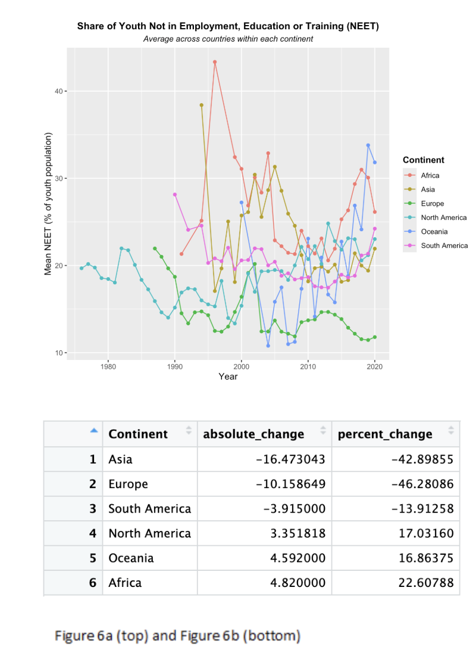
Figure 6a presents the evolution of average youth NEET rates across continents from the earliest available year up to 2020, allowing an assessment of progress toward SDG Target 8.6, which aims to” substantially reduce” youth disengagement by 2020. Beginning with the regions that exhibit declines, Europe achieves the largest proportional reduction, decreasing its NEET share by approximately 46% over the period. The trajectory is characterised by a mainly downward trend, with only a modest increase in the late 2000s. This brief rise coincides with the 2008 Global Financial Crisis. Asia demonstrates the largest absolute reduction in its NEET share, falling by 16.5 percentage points. Its trend begins with a sharp fall, followed by a volatile upward movement throughout the 1990s and 2000s, periods closely aligned with regional economic shocks such as the 1997-98 Asian Financial Crisis, before declining again in the late 2000s. This later improvement may reflect broader economic recovery and the expansion of youth-focused policy frameworks across several Asian countries. South America shows a moderate decrease of 3.9 percentage points, following a relatively stable path with limited fluctuations, except a mild uptick appears in the late 2010s. This reflects the deep economic downturn major economies in the region, such as Argentina and Brazil, were facing at the time.
Turning to regions where NEET levels increased, North America exhibits a 17% rise over the period. After a brief initial decline, the trend reverses and drifts steadily upward, suggesting relatively limited improvement in youth labour-market integration. Africa demonstrates the largest upward movement in absolute terms, increasing by 4.8 percentage points. The trend features a sharp rise in the late 1990s, a modest decline, and then a steady upward climb through the 2010s, consistent with persistent structural challenges in youth employment across the continent. Oceania records an increase of 4.6 percentage points, beginning with a noticeable decrease before entering a volatile upward climb, ultimately ending the period with the highest NEET share globally.
Figure 6b summarises these changes numerically, clearly showing that only three continents achieved reductions by 2020: Europe, Asia and South America. However, South America and Asia maintain relatively high shares of youth NEET at the end of the period. Under the external benchmarks we applied, which consider reductions above 15% as sub9tantial (and 29% for Europe), only Europe and Asia demonstrate meaningful progress toward SDG Target 8.6.
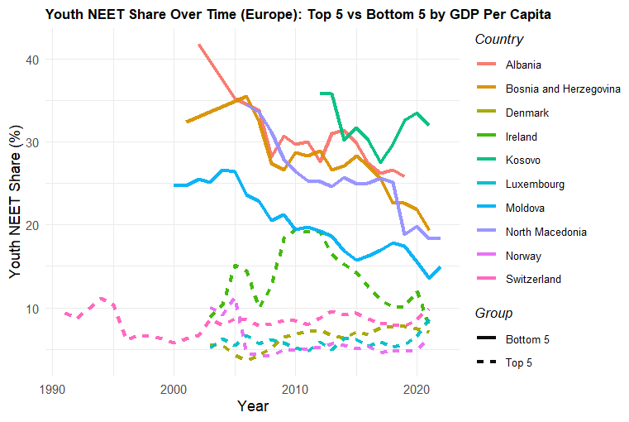
Furthermore, we analysed Europe’s youth NEET specifically by comparing the Top 5 nations with the highest GDP per capita against the Bottom 5. Our analysis showed that only 4 of the top 5 nations reduced their NEET below 9%, between 1990 and 2020. Whereas the bottom 5 nations had a range between 16-33%.
The top 5 have the tax revenue to invest towards education quality and social programmes. For example, Switzerland utilises Dual Vocational Education and Training (VET) and apprenticeship programmes where their vocational education blends paid job training, which is popular amongst the youth. This creates smooth transitions from school to workforce and resulted in a low youth NEET of 9% and thus met target 8.6.
Figure 7
Conversely, although Ireland reduced their youth NEET to 12% in 2020, they previously suffered from a spike in youth NEET to 20% in 2011. A factor was the financial crisis. The crisis led to high unemployment levels amongst all age groups. Additionally, between 2007 and 2012, the construction sector collapsed (Kelly and McGuinness, 2015). Employment fell by approximately 61%, which removed many entry-level jobs/apprenticeships, which disproportionately employed young men and thus substantially increased youth NEET.
In contrast to the top 5, there was a rise in skill mismatch among the bottom 5. Emerging economies are reliant on manufacturing sectors. However, growing youth employment shifted towards the services sector. This means that the supply of youth labour far exceeds demand, causing relatively higher youth NEET amongst the bottom 5 nations.
However, Moldova, Albania and Bosnia & Herzegovina are emerging countries who achieved significant progress in their NEET reduction, substantially lowering it by 36%, 38.1% and 30.3% respectively. As a result, they were successful in achieving SDG target 8.6 and the Antalya goal. Similarly to the developed nations, these countries combined guaranteed youth offers, improved employment & VET services and have prioritised inclusion, particularly towards female labour force participation. Such measures have reduced youth NEET, which is why they are outliers amongst the bottom 5 European nations.

3c RESULTS – EXTRA ANALYSIS
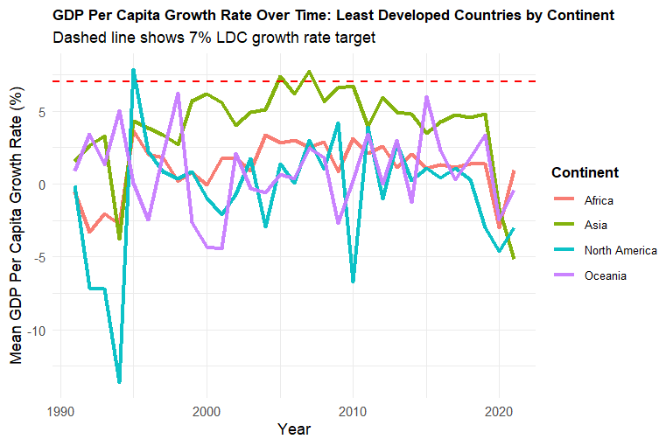
We then produced an additional analysis from our custom CSV file. We classified LDC’s and plotted their GDP growth rates. As evidenced by the line graph (Figure 8), the continents reached the 7% growth rate target only 3 times. North America’s LDCs also frequently had negative GDP growth rates. It is clear from the graph that LDCs did not meet the GDP growth rate target, and the only LDCs that are close to reaching the target are the Asian LDCs.
Figure 8
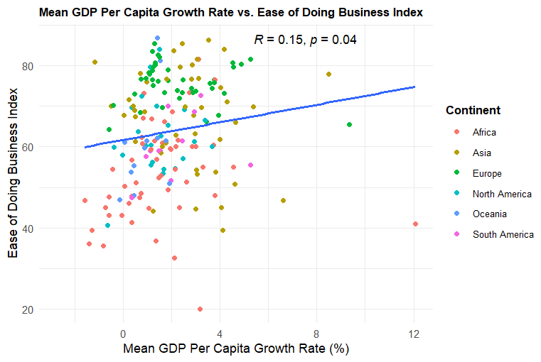
Figure 9 shows the relationship between GDP per capita growth rate and the ease of doing business index, which is calculated using multiple business-related indicators. We hypothesise that GDP growth is positively correlated with the ease of doing business index, which is what we observe in the positive Pearson coefficient of 0.15 and a statistically significant value p-value of 0.04. The scatter plot also shows that Asia and Europe’s correlation are antithetical. For Europe, its developed economies with lower GDP growth rates have a higher ease of doing business index, producing a negative correlation. Asia’s correlation can be explained by outliers such as Timor-Leste and Myanmar with a high GDP growth rate but a low ease of doing business index.
Figure 9
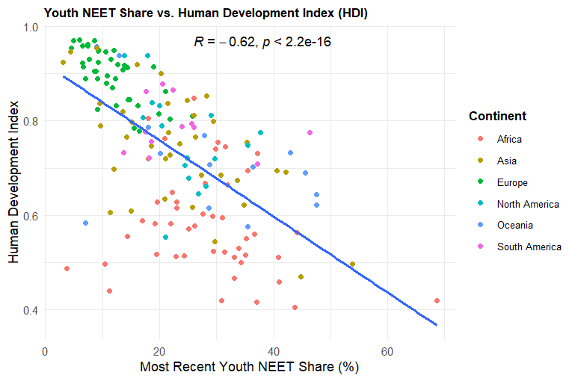
Finally, Figure 10 shows a dramatic correlation and a highly statistically significant result. It explains that as HDI increases, youth NEET share goes down. We can deduce from the graph that there is a higher negative correlation for Europe than less developed continents like Africa, whilst the variance in data is higher for Africa and North America. This shows that if countries improve their life expectancy, education, and gross national income (HDI) then youth NEET shares should drop.
Figure 10

4 DISCUSSION
Some limitations of our research include lack of data. Many low-income or conflict-afflicted countries (e.g., Somalia and Afghanistan) tend to have missing GDP per capita in their early years before the 2000s. This means that for the 1990s, these countries do not contribute to the continent average, making Africa and Asia’s early period results incomplete. The youth NEET dataset also missed entire decades for many countries. Additionally, the NEET dataset begins in 1976, but most continents have no NEET data until the mid-2000s. Furthermore, GDP per capita growth alone does not fully capture economic sustainability or structural change. The indicator does not reflect inequality, population dynamics, informal-sector activity or quality of employment; components that are also central to SDG 8. As a result, the graph reflects only one dimension of the target. Another limitation was the vagueness of the UN SDG explanations. There were no concrete values given by the UN for what a substantial reduction in share of youth NEETs is or a good GDP per capita growth in accordance with national circumstances is, so we set our own values based on existing research.
5 CONCLUSION
From 1980–2020, no continent achieved sustained success on UN growth goals and the LDC benchmark of 7% annual per‑capita GDP growth, whilst Europe’s lower half met the 3% growth goal. Asia showed rapid yet unsustained growth spurts, whilst continents such as Africa and South America were much more volatile. Continents with mainly MDCs tended to be steady in their per-capita growth. Youth NEET reduction followed a similar pattern, with a few nations meeting the 9% target and 15% reduction. Its progress was erratic, with Europe being the most consistently improving whilst continents such as Africa were furthest away from achieving significant progress in youth employment. In Europe, higher‑income countries generally reduced NEET more, supported by strong school‑to‑work systems, such as high-quality VET, while lower‑income nations faced skill mismatches. Some notable exceptions were Moldova, Albania, and Bosnia & Herzegovina, who advanced through coordinated youth offers, strengthened VET and inclusive policies. Overall, continental progress is best judged through sustainable growth and broad NEET reductions, rather than a global objective towards the 7% and 15% targets.

6 APPENDIX I - GITHUB
GitHub Usernames: slee7286 (Siheon Lee), jessicazhang1235666 (Jessica Zhang), mahrongxuan (Rong Xuan), chiakalae (Chiakala Emezie), alif19-code (Alif Mohammed)
GitHub Link: https://github.com/slee7286/IDS_Project

7 REFERENCES
European Commission (2017) ‘European Pillar of Social Rights’ Available at: https://op.europa.eu/webpub/empl/european-pillar-of-social-rights/en/ (Accessed: 10 December 2025).
European Commission (2020) European Economic Forecast – Spring 2020. Brussels: European Commission. Available at: https://economy-finance.ec.europa.eu/system/files/2020-05/European_Economic_Forecast_Spring_2020.pdf (Accessed: 7 December 2025).
IMF (2016) Latin America and the Caribbean in 2016: Adjusting to a Harsher Reality. Available at: https://www.imf.org/en/blogs/articles/2016/01/22/latin-america-and-the-caribbean-in-2016-adjusting-to-a-harsher-reality (Accessed: 6 December 2025).
International Labour Organisation (ILO) (2016) Global Employment Trends for Youth 2016. Geneva: ILO. Available at:
https://www.ilo.org/sites/default/files/wcmsp5/groups/public/%40dgreports/%40dcomm/%40publ/documents/publication/wcms_513739.pdf pp 3-6. (Accessed 8 Dec 2025).

International Labour Organisation (ILO) (2025) Youth at Work in G20 countries. Geneva: ILO. Available at: https://www.ilo.org/sites/default/files/2025-07/250729_G20_Youth%20at%20Work%20report_final.pdf (Accessed 8 Dec 2025).

Kelly, E. and McGuinness, S. (2015) ‘Impact of the Great Recession on unemployed and NEET individuals’ labour market transitions in Ireland’, Economic Systems, 39(1), pp. 59–71. Available at: https://www.sciencedirect.com/science/article/abs/pii/S0939362514000971 (Accessed: 6 December 2025).
OECD (2009) The Financial Crisis: Reform and Exit Strategies. Paris: OECD Publishing. Available at: https://www.oecd.org/content/dam/oecd/en/publications/reports/2009/09/the-financial-crisis_g1ghb564/9789264073036-en.pdf (Accessed: 8 December 2025).
OECD (2023) ‘Youth at Work in the G20: Progress and Policy Action towards the Antalya Goal’ OECD Publishing. Available at: https://www.oecd.org/content/dam/oecd/en/publications/reports/2023/07/youth-at-work-in-the-g20-progress-and-policy-action-towards-the-antalya-goal_f17263c8/e9552f40-en.pdf (Accessed: 8 December 2025).
UN DESA (2014) World Economic Situation and Prospects: Country Classification. Available at: https://www.un.org/en/development/desa/policy/wesp/wesp_current/2014wesp_country_classification.pdf (Accessed: 8 December 2025).
UN DESA (2024) List of Least Developed Countries and Country Fact Sheets. Available at: https://policy.desa.un.org/themes/least-developed-countries-category/list-of-ldcs-and-country-fact-sheets (Accessed: 7 December 2025).
UN DESA (2025) Extended Report 2025: Goal 8. Available at: https://unstats.un.org/sdgs/report/2025/extended-report/Extended-Report-2025_Goal-8.pdf (Accessed: 8 December 2025).
UN DESA (2025) The Sustainable Development Goals Report 2025. New York: United Nations Publications. Available at: https://unstats.un.org/sdgs/report/2025/The-Sustainable-Development-Goals-Report-2025.pdf (Accessed: 3 December 2025).
UNDP (2025) Human Development Report 2025. Available at: https://hdr.undp.org/content/human-development-report-2025 (Accessed: 8 December 2025).
World Bank (2002) Transition: The First Ten Years — Analysis and Lessons for Eastern Europe and the Former Soviet Union. Washington, DC: World Bank. Available at: https://documents1.worldbank.org/curated/en/319481468770972868/pdf/multi0page.pdf (Accessed: 8 December 2025).
World Bank (n.d.) Open Knowledge Repository Resource. Available at: https://openknowledge.worldbank.org/server/api/core/bitstreams/75ea67f9-4bcb-5766-ada6-6963a992d64c/content (Accessed: 8 December 2025).

‌

